Author: Cédric Vincent

**Lattier, Christian**  (1925-1978)

Christian Lattier, nicknamed the "bare-handed sculptor" by the art historian Yacouba Konaté, has been one of pioneers of the modern art in Ivory Coast. The success of his career was formally recognized in 1966 when he won the grand prize of arts at the First World Negro Art Festival in Dakar. Despite this, he died at age 53 in an almost general indifference in his country. He enrolled at the École des Beaux-Arts in Saint-Etienne (France) in 1947. One year later, he went on to study sculpture and architecture at the École Nationale Supérieure des Beaux-Arts in Paris. Paris is also where Lattier first achieved artistic success. Not long after his arrival, his original sculptures designed with wood, stone, wire and a strong hemp fiber attracted considerable attention. Among his most famous works is *Panthère,* the larger-than-life crouching rope panther for which he was awarded the Chenavard prize in 1954, a prize awarded to the best students of art and architecture at the École des Beaux-Arts in Paris. In 1959 he was a part of the first Paris Biennale. Today, some artists, such as the Beninese Dominique Zinkpè, recognize his influence on their work. Nineteen of Lattier's sculptures are deposited at Musée National de Côte d'Ivoire in Abidjan.

Lattier designed sculptures made of strings and wire concealing the underlying iron structure. "If I had made them [the sculptures] of wood, it would be accused of copying my ancestors. If I had begun to carve stone, it seemed to me that I copied White people. I had to find something new". Lattier's corpus embraces a remarkable diversity of subjects and themes. He created monumental works on religious and historical themes, as well as representations of "ronde-bosse" traditions and humoristic figures. *Panthère* seems far removed in spirit and intention from the emaciated *Le Christ* or his series of graceful, non-fearsome masks.

One of these curiously fanciful pieces is a work entitled *Le voleur de coq, dit la Victoire de Samothrace* (The Chicken Thief or the Victory of Samothrace) (1962), and stands about 4.2 feet high. The title clearly refers to the statue *The Winged Victory of Samothrace*, a main piece of Hellenistic sculpture. However, instead of the goddess of victory, with her ardent movements frozen in marble, the viewer of Lattier’s *Victory* is faced with what indeed looks more like a chicken thief: a ridiculously slender, miserable wretch in a brazen, straddling posture, seemingly on the verge of taking to its heels at any moment. Lattier’s ironical approach to centuries-old traditions was not limited to European culture. West African ritual masks were also subject matter of his artistic reinterpretation. Around 1975, Lattier created a series of works entitled *Masque*, again combining his techniques and traditional – in this case African – motifs with elements of Abstraction and Minimal Art.

Lattier returned to Côte d'Ivoire in 1962 in the euphoric wake of independence, but his prickly character put him at odds with the Ivoirian art establishment. Although he had exhibited in Europe, North America and Brazil, his career at home, especially during the final decade of his life, was marked by conflicts.

References and Further Reading

Konaté Y., *Christian Lattier: Le sculpteur aux mains nues*, Saint-Maur: Edition Sépia, 1993.

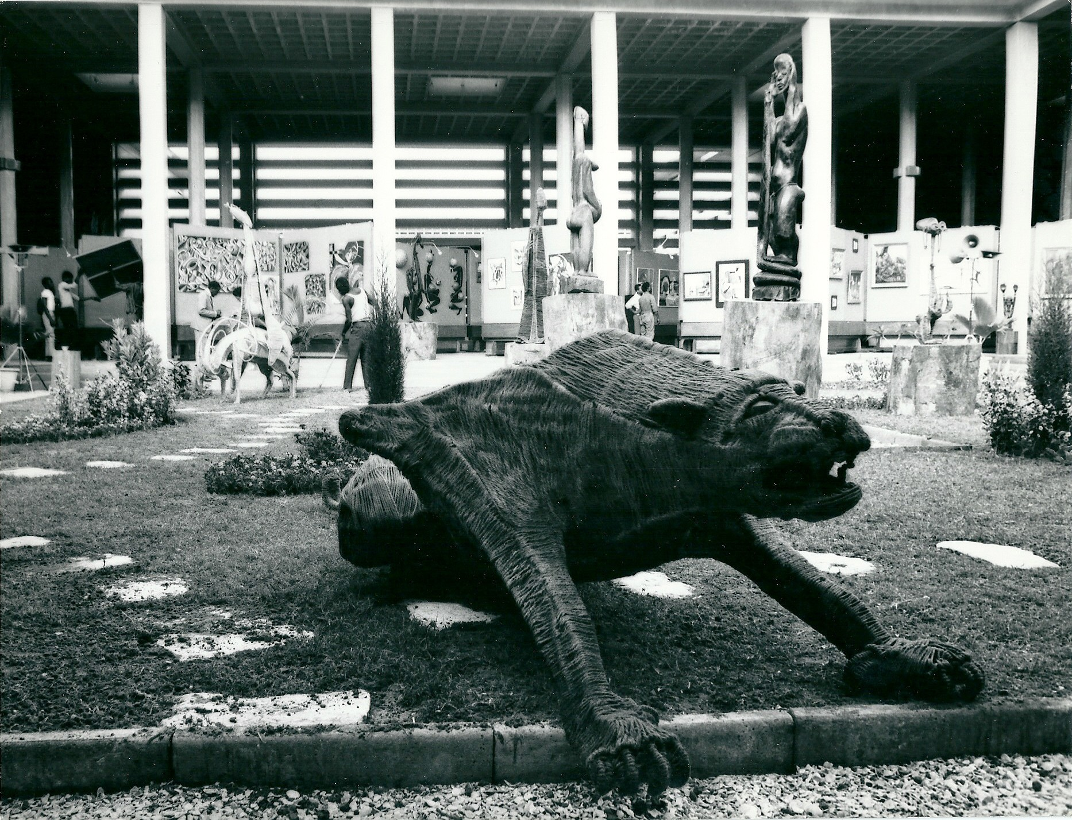

Christian Lattier, *Panthère*, Festival mondial des arts nègres, Dakar 1966 / credit Jean Mazel - *Archives des Festivals Panafricains*